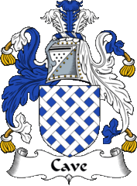 | CAVE FAMILY HISTORY SOCIETY
TO |  |  | Bank

Address

Postcode
Please make payment of £10.00 from my account

Number
To | Virgin Money, Coventry,  Sort Code 05-07-40
For the credit of | CAVE FAMILY HISTORY SOCIETY  ACCOUNT NO. 46850010
Membership  NO. |  | (Please ensure this is included as the payment reference)

Date of payments 1st June 2022, and annually thereafter until further notice
PLEASE NOTE:
This cancels any previous order in favour of the above named Beneficiary.

Date

Name

Signature

Please complete and return to:
Alan R Moorhouse
[Cave FHS Membership Secretary]
8 Strachans Close
STROUD
Gloucestershire
GL5 3EB

